Intro to Web Development

CARIT
A website made using HTML and CSS.

Jack Morris

IT 3203 Fall 2021

Professor Malos

10/24/2021

Summary of CARIT site:

I created a website using floats instead of flex or grid layouts. I have 3 pages with links to Assignment 1, 2, Milestone1, and a few other webpages. The assignments link back to the website. The home page or index.html has a description of the center in the header on every page. It has a sidebar on the left that uses a list with news items that link to a website. I use <p> tag throughout all 3 pages including the home page middle column. The <br> tag is demonstrated through the middle column. There is also a footer on every page. The header image links to the http://ccse.kennesaw.edu/it website.

For the 2nd page, I list 3 faculty members with information inside a container that includes the requirements with a link to their website they listed on the KSU website.

For the third page, I decided to use a table to list out upcoming and completed assignments as well as GitHub Pages and my own personal GitHub. I also have a few containers of information describing the assignments. All three pages have the name of the center in the header with the star logo. Each page also includes the gray menu bar that adapts to which page you are. All the navigation bars have some type of style and hover style, including the logo. Also some links have styles and hovers through the pages. All of the main layout displays the same styles and hovering styles for each page.

URL: https://it3203fall21jmorr123.azurewebsites.net/

index.html
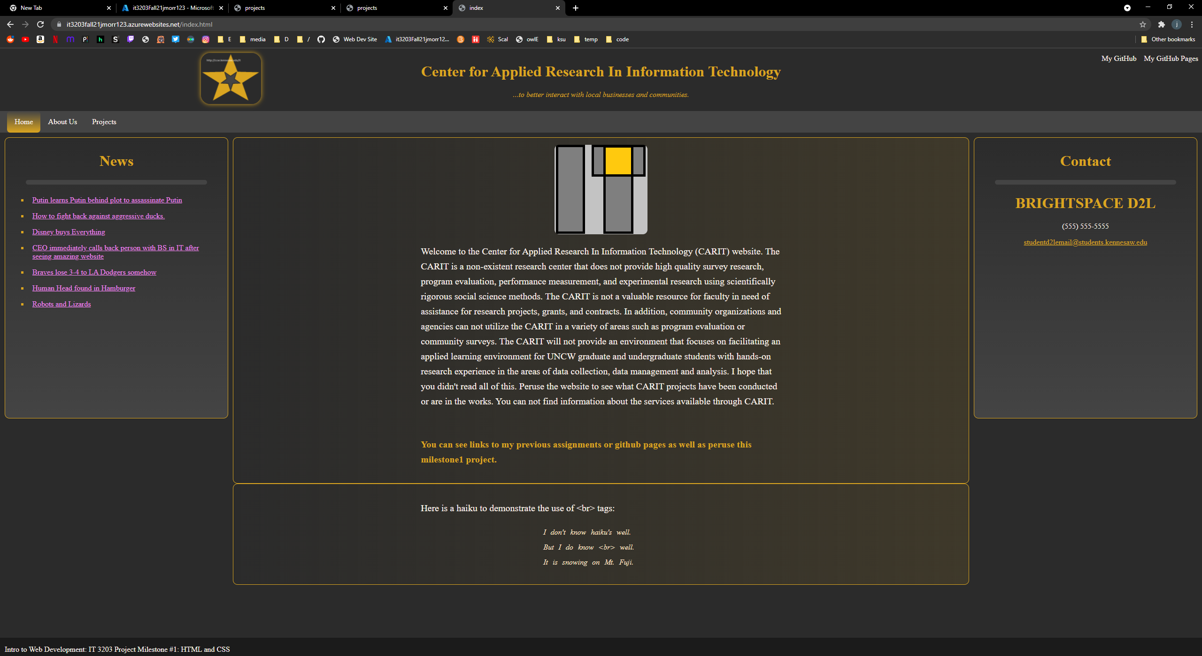
1st Page: A home page named “index.html”.

Here is my home page. This has the same layout for every page as you will notice. The title of the page is “index.html”.

The General Layout

The header, menu bar, top navigation, and menu navigation bar:
The description of the CARIT site is in the header at the top of the page with some accompanying text in italics. There is also an image that looks like a star inside a star that links to http://ccse.kennesaw.edu/it. It includes a box shadow and some hovering style. It has some text I left over that is part of the image. There is a few extra things I added to the web page such as the top right white links that link to other websites. These have their own hover styles that change background color and color when hovered over. The bar that is #444 or a lighter gray is menu navigation bar for Milestone 1. It is currently gold under “Home” indicating that this is the page you are on currently. If you hover over the other words, they will highlight the same color. This page uses floats and border boxes with <div> tags to create the layout. I considered using Flex or Grid, but wanted to get more used to using float. I may recreate the site using flex or grid later.

The sidebars, middle column, and the footer:
This page has a middle column with an image and a description of the center and some additional information. The next container below the middle column includes a haiku demonstrating how to use <br> tags from the requirements. There is a footer at the bottom which has some information about this class, it is a fixed position footer that does not block any information, as seen in upcoming pages. The side bars contain the same information on every page, as only the middle column differs in content. Each page side bar links have the same but different from the default for visited links as well as non visited links. Golden for non-visited and violet for visited. The links of the News sidebar, have a golden square style next to them as well.

About Us
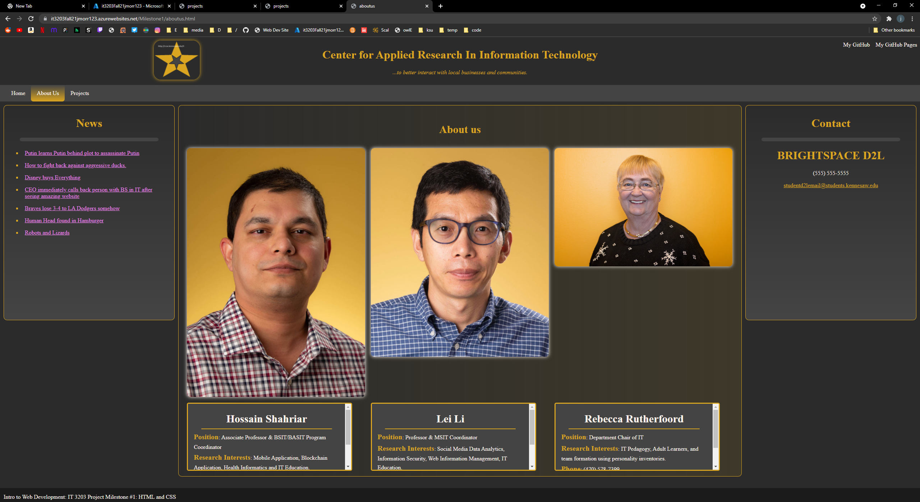
2nd Page: A page called “aboutus”.

What differs:

The layout has stayed the same, however, as you may notice the navigation menu bar has changed to About Us and it is now highlighted. There is new images of KSU faculty with their own information bars that are set to auto therefore giving them scroll bars. Their names are links to their websites. When hovering over the name links, they decrease in font size, but will stay the same color when clicked on so as not to disrupt the cleanliness of the website. This page looks like this in 1440p monitors, however, in 1080p monitors, there will be some space between the bottom of the image and the information container. I didn’t notice this until I visited the website on another computer. I will fix that in the future. The middle column also contains a description called About us specifying what this page is about. Each image with its associated information box has its own container. The link to their email in the information box also has a gold color for the link. There is a barely noticeable box shadow around the images with the color of seashell (white).

Projects
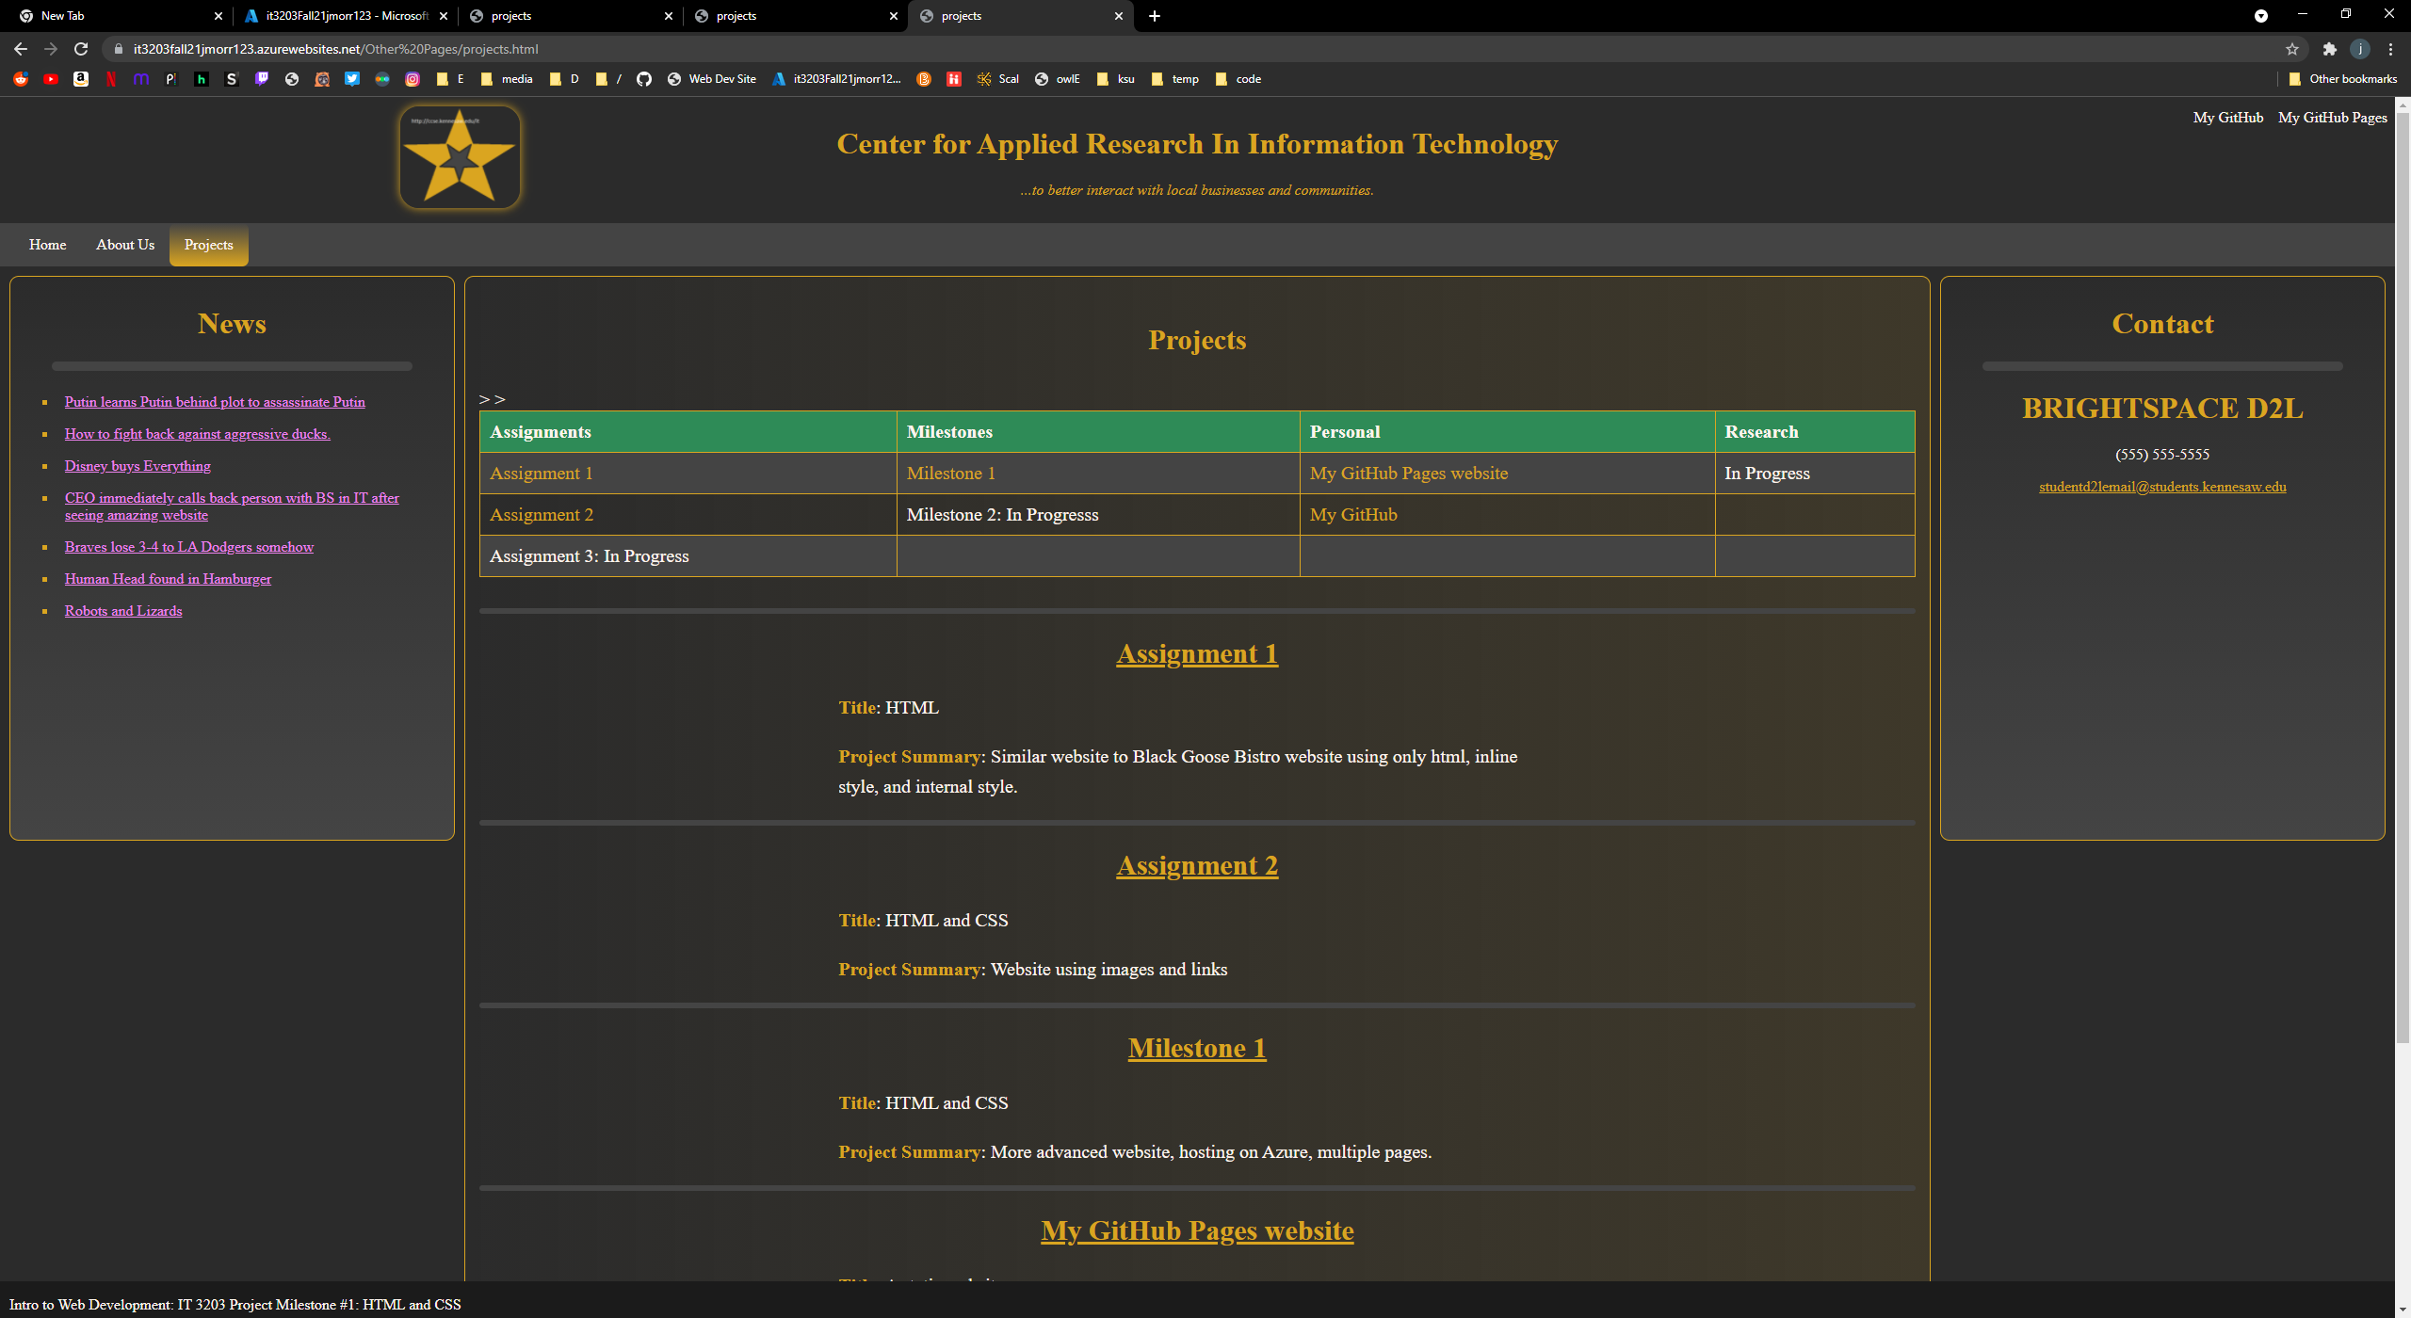

3rd Page: A page called “projects”.

What Differs:

This layout is also similar to the other two pages. The menu bar active color has changed to the “Projects” tab. This page contains a table with links to all assignments, websites, milestones and other things that are yet to be completed. When hovered over a cell in the table, the cell background color changes. If you hover over a link inside of a cell, the link changes color and the background color changes. It also contains descriptions of the projects and a summary for them. Although not part of this milestone, Assignment 1 and Assignment 2 do work if clicked on and have their own link back to the projects page. The GitHub Pages link will have a link back to the projects page and the home page as well.

Works Cited:

Faculty and staff. Department of Information Technology. (n.d.). Retrieved October 25, 2021, from https://ccse.kennesaw.edu/it/faculty-staff.php.

